File permissions in Linux

Project description
The team is updating permissions for files in the system. Some files have incorrect permissions set, so they are being reviewed to ensure they reflect the level of authorization. This operation keeps systems secure.

Check file and directory details
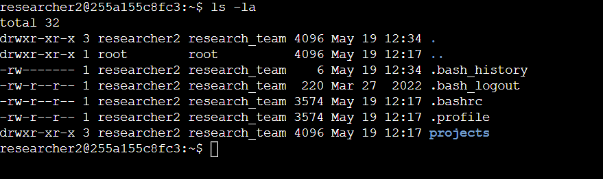
The ls -la command was used to return a detailed list of files and directories, including hidden files.

Describe the permissions string
- 1st character – d or (-) to identify if it’s a file or a directory.
- 2nd to 4th character – rwx permissions for the user.
- 5th to 7th character – rwx for the group.
- 8th to 10th character – rwx for the others.

Change file permissions
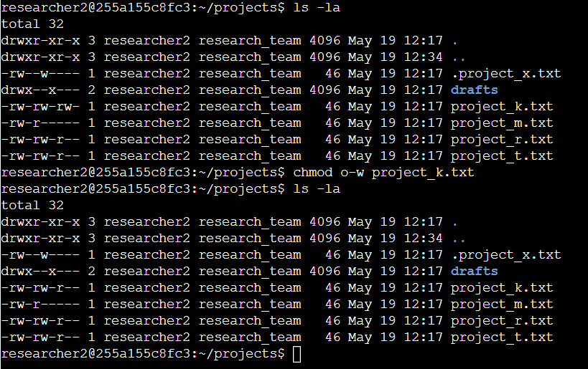
The project_k.txt file was not supposed to have write permissions and so we changed that using the chmod command. After the changes, we checked if the permissions have been changed.

Change file permissions on a hidden file
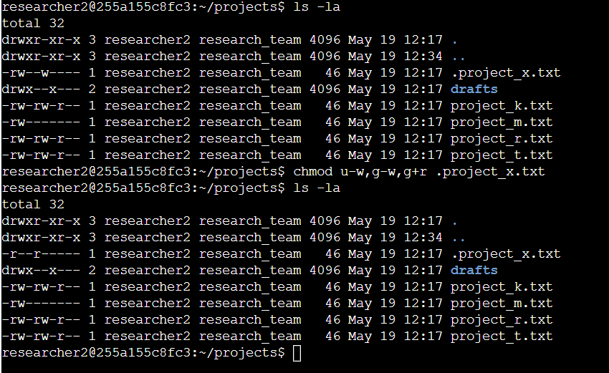
The hidden file .project_x.txt was only meant to have read permissions for the user and the group.

Change directory permissions
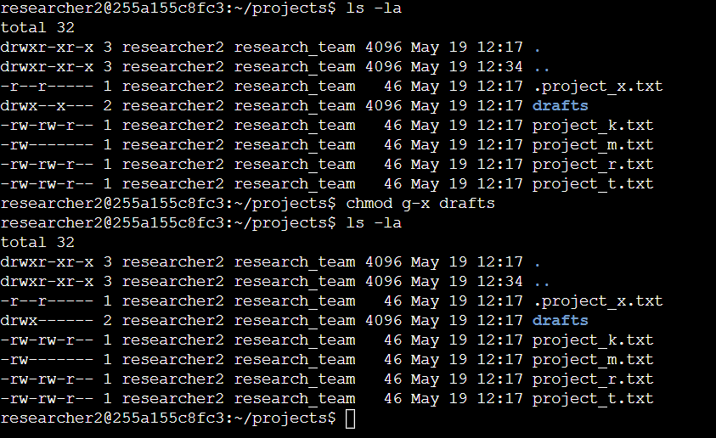
Only the user was supposed to have rwx permissions for the drafts file.

Summary
We managed to apply proper access controls to the files and directories. The chmod command was key, and we also utilized ls -la to be able to view files with their permissions and even hidden files.

